File created: 18.08.2021., 15:26 CET by Fatima Velic

Last modified: 19.10.2021., 14:21 CET by Fatima Velic

**Design document**

**ORC calculation program**

**1. Document Revision History**

Version 0 (initial version) – source code operable and executable inside an IDE editor and as a console application. Contents: routines for necessary calculations and hardcoded variable inputs. Calculation results exported as excel file and displayed in the console.

Version 1 (August 12th, 2021.) – performance optimisation in all modules, calculations execute <2 s with fixed inputs.

Version 1.1. (August 17th, 2021.) – added user inputs for mass flow, temperature and pressure variables with exception handling for non-numeric symbols, negative numbers and upper and lower limits. Included exception handling for results file and folder creation. Added feature to graph the results as a T-s diagram. Added documentation files: Technical overview, Requirements document, Design document and Variable summary.

Version 1.1.1 (August 30th, 2021) – fixed circuit bugs, added bounding conditions and T-Q diagram.

Version 2.0. (September 15th, 2021) – setup for web application completed. Basic model, templates and views created.

Version 2.1. (September 20th, 2021) – calculation modules integrated. Authorisation and authentication setup correctly, User registration forms added.

Version 2.1.1. (September 27th, 2021) – added custom validators, miscellaneous messages, searching and filtering options.

Version 2.1.2. (October 19th,2021) – incorporated solutions suggestions based on calculation, added more custom validators, introduced contact form, statistical graphs and personal style customisation

**2. Objectives**

This website has two objectives. 1. To provide a platform where users would be able to perform calculations and, based on results, get suggestions on which machine would be the most suitable for their needs. 2. To all website administrators and managers to gather data consisted of inputs and results, analyse it and make assumptions about market demands.

**3. System Decomposition/Design**

**4. Dynamic model/Sequence diagram**

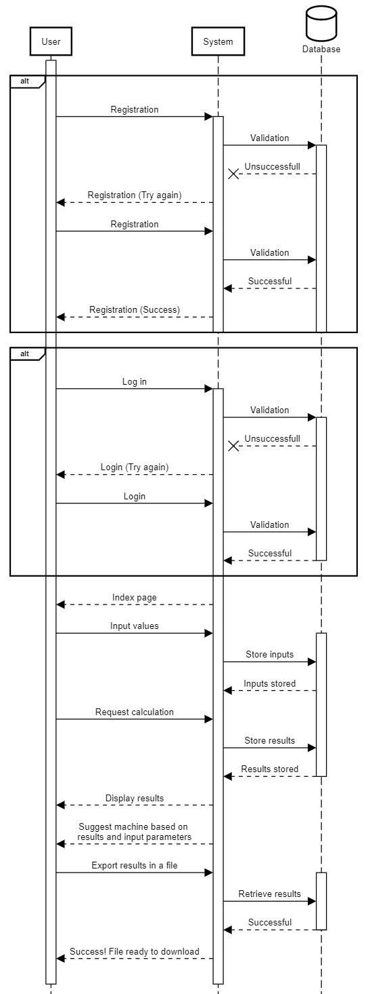

**5. User interface**

GUI prototype contains views from both user and administrator role.

Index view - anonymous user

Login

Index– logged in user (client)

My calculations – logged in user

Details with inputs, calculation results, diagrams and machine suggestions

Calculation history - administrator

Statistics and graphs – administrator

List of users - administrator

User details – administrator

Delete user - administrator

Contact – administrator

Registration form – administrator

